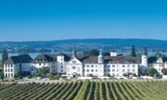
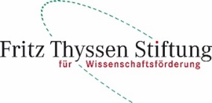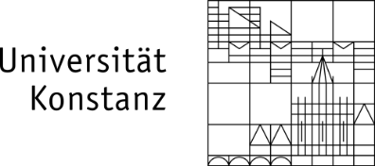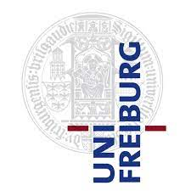

Conference on Intrinsic Time in Finance
Abbey Hegne, Allensbach, 6 – 7 May 2022
Registration Form for Invited Speakers
First name

Surname

Affiliation

Address

Email

Vegetarian meal yes no

Partners yes no
If yes, name(s) of partners

Vegetarian meal partner yes no

The partner fee is 190 Euros/person and it includes all lunches, the conference dinner on Friday, 6 May 2022 and the social programme on Saturday afternoon, 7 May 2022.

Please pay the fees for the partner via bank transfer as it follows:

For all residents in Non-EU For all residents in EU
SEPA - Bank Transfer
Recipient: Universitaetskasse Konstanz Recipient: Universitaetskasse Konstanz
Bank: BW-Bank Konstanz Bank: BW-Bank Konstanz
Bank City: Konstanz IBAN: DE92 6005 0101 7486 5012 74
Account No.: 7486501274 BIC: SOLA DE ST
BLZ: 60050101

Reason for payment: intrinsic time

