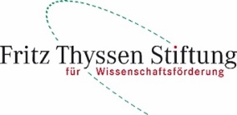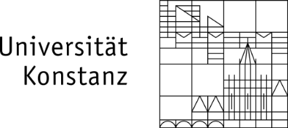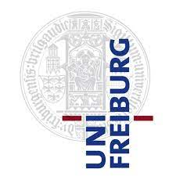

Conference on Intrinsic Time in Finance
Abbey Hegne, Allensbach, May 6 – 7, 2022
Registration Form for Non-Invited Speakers
First name

Surname

Affiliation

Address

Email

Vegetarian meal yes no

Partners yes no
If yes, name(s) of partners

Vegetarian meal partner yes no

The conference fee is 275 Euros/person for the conference participants and 190 Euros/person for partners. The fees include all lunches, the conference dinner on Friday, 6 May 2022 and the social programme on Saturday afternoon, 7 May 2022. The conference fee also includes the coffee breaks.

Please pay the fees via bank transfer until April 15, 2022 as it follows:

For all residents in Non-EU For all residents in EU
SEPA - Bank Transfer
Recipient: Universitaetskasse Konstanz Recipient: Universitaetskasse Konstanz
Bank: BW-Bank Konstanz Bank: BW-Bank Konstanz
Bank City: Konstanz IBAN: DE92 6005 0101 7486 5012 74
Account No.: 7486501274 BIC: SOLA DE ST
BLZ: 60050101

Reason for payment: intrinsic time

